CONFIDENTIAL  CS/NOV 2026/ICT450

UNIVERSITI TEKNOLOGI MARA
MARKING SCHEME

COURSE :
COURSE CODE :
EXAMINATION :
TIME :
DATABASE DESIGN AND DEVELOPMENT
ICT450
NOVEMBER 2026 (MOCK)
3 HOURS

MARKING SCHEME NOTES

- This marking scheme accompanies the ICT450 mock paper (November 2026).
Answers are unofficial model answers, not official UTM marking schemes.

- Marking points state the expected answer and the allocation of marks; every question retains its source paper and page reference.

- Five questions x 20 marks; total = 100 marks.
- Real-bank questions: 5. Placeholders: 0.
Questions and answers are for local study use only.

- Structure derived from 12 unique ICT450 past papers; every real question remains traceable to its source page.

FOR MARKERS' USE ONLY

This marking scheme consists of 7 printed pages.
MARKING GUIDE
QUESTION 1 (20 marks)
Source: ICT450-2018-JUN · page [2] · bank id ICT450-2018-JUN-Q1
Reference answer
(a) Two problems associated with a file system. [4 marks]
• Extensive programming and program-data dependence — each file needs its own management program, and changing a file structure breaks the programs.
• Data redundancy and inconsistency — the same data is stored in several files and updates are not coordinated.
• Complex administration and weak security — file access is decentralised and difficult to control.
(b) Basic structure of the ER model and two advantages. [4 marks]
• The ER model represents data as entities, attributes and relationships; entities are objects, attributes describe them and relationships connect them.
• Advantage: it is a clear communication tool between designers, programmers and users.
• Advantage: it is independent of the DBMS and provides a conceptual blueprint before implementation.
(c) TRUCK, BASE and TYPE tables. [12 marks]
• i) TRUCK to BASE is many-to-one: each truck has one Base_Code, while one base can have many trucks. TRUCK to TYPE is also many-to-one: each truck has one Type_Code.
• Entity integrity: TRUCK YES (Truck_Num is unique and non-null); BASE YES (Base_Code is unique and non-null); TYPE YES (Type_Code is unique and non-null).
• Referential integrity: every TRUCK.Base_Code exists in BASE and every TRUCK.Type_Code exists in TYPE.
• ii) ERD:
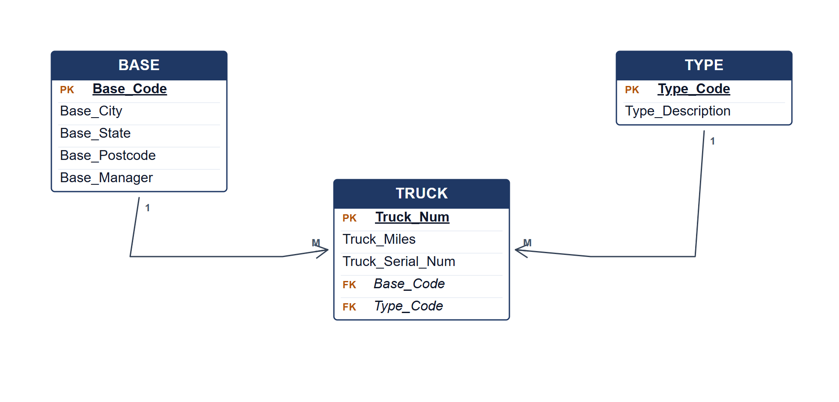
Crow's Foot ERD for TRUCK, BASE and TYPE.
Marking guide
• a) 2 marks for each of two file-system problems (2 × 2 = 4).
• b) 2 marks for the ER structure and 2 marks for each advantage (2 + 2 = 4).
• c)(i) 3 marks for the relationship types and 2 marks for the entity-integrity explanation (5).
• c)(ii) 7 marks for entities, keys, relationships, connectivity and cardinalities.
Provenance: model_unofficial · confidence high · Model-authored from the approved question text, the supplied source assets and the ICT200/ICT450 knowledge base; no official ICT450 marking scheme was supplied.
Knowledge base basis: TOPIC 1 DATABASE CONCEPT (1).pdf; TOPIC 2 DATA MODEL (1).pdf; TOPIC 3 RELATIONAL DATA MODELstu.pdf
Assumptions / notes
• The TRUCK table has a composite foreign key to BASE and TYPE; both are mandatory.

QUESTION 2 (20 marks)
Source: ICT450-2019-JUN · page [3] · bank id ICT450-2019-JUN-Q2
Reference answer
(a) Data model importance and ANSI/SPARC levels. [10 marks]
• i) A data model is a communication tool and blueprint that organises data for users, designers and programmers.
• ii) External level — the user or application view; each user sees only the data and operations needed for their task.
• Conceptual level — a community view of the whole database: entities, attributes, relationships and constraints, independent of physical storage.
• Internal level — the physical view: file organisation, indexes, storage allocation and access paths.
(b) Appropriate situations for centralized and decentralized design. [4 marks]
• Centralized design suits a single-site organisation with tight control, uniform security and moderate data volume.
• Decentralized design suits multiple branches or regions where local access, autonomy and resilience matter more than central control.
(c) DBLC stages in sequence. [6 marks]
• Database initial study.
• Database design.
• Implementation and loading.
• Testing and evaluation.
• Operation.
• Maintenance and evolution.
Marking guide
• a)(i) 2 marks for importance; (ii) 8 marks for the three levels with illustration (2 + 8 = 10).
• b) 2 marks for each appropriate situation (4).
• c) 1 mark for each of six stages in order (6).
Provenance: model_unofficial · confidence high · Model-authored from the approved question text, the supplied source assets and the ICT200/ICT450 knowledge base; no official ICT450 marking scheme was supplied.
Knowledge base basis: TOPIC 2 DATA MODEL (1).pdf; TOPIC 6 DATABASE DESIGN (1).pdf

QUESTION 3 (20 marks)
Source: ICT450-2025-FEB · page [3] · bank id ICT450-2025-FEB-Q3
Reference answer
The logbook records one row per customer visit, but the order list is a repeating group and customer/staff/menu data is repeated.
(a) Three problems in the logbook. [3 marks]
• The “List of orders and Quantity” is a repeating group, so the table is not atomic.
• Customer, staff and menu details are duplicated, creating redundancy and update anomalies.
• Totals can be inconsistent because they are manually copied from the order lines.
(b) Keys and dependencies. [6 marks]
Flattened logbook.
LOGBOOK (Date, CustomerName, TotalOrders, OrderList, TotalPayment, PaymentType, StaffName)
Functional dependencies.
Assumed OrderID is the order key
CustomerName → customer details
StaffName → staff details
MenuCode → MenuName, Price
OrderID → Date, CustomerName, TotalPayment, PaymentType, StaffName
OrderID, MenuCode → Quantity
(c) Normalise from 1NF to 3NF. [11 marks]
1NF: one row per order item; use OrderID and MenuCode.
1NF relations.
ORDER (OrderID, Date, CustomerName, TotalPayment, PaymentType, StaffName)
ORDER_ITEM (OrderID, MenuCode, Quantity)
MENU (MenuCode, MenuName, Price)
2NF: remove customer, staff and menu partial dependencies.
2NF relations.
CUSTOMER (CustomerName)
STAFF (StaffName)
MENU (MenuCode, MenuName, Price)
ORDER (OrderID, Date, CustomerName, StaffName, PaymentType, TotalPayment)
ORDER_ITEM (OrderID, MenuCode, Quantity)
3NF: separate customer, staff and menu masters; no transitive dependency remains.
3NF relations.
CUSTOMER (CustomerName)
STAFF (StaffName)
MENU (MenuCode, MenuName, Price)
ORDER (OrderID, Date, CustomerName, StaffName, PaymentType, TotalPayment)
ORDER_ITEM (OrderID, MenuCode, Quantity)
Marking guide
• a) 3 marks: three problems stated.
• b) 6 marks: key and dependency identification.
• c) 11 marks: 1NF (2), 2NF (4), 3NF (5).
Provenance: model_unofficial · confidence medium · Model-authored from the approved question text, the supplied source assets and the ICT200/ICT450 knowledge base; no official ICT450 marking scheme was supplied.
Knowledge base basis: TOPIC 5 NORMALIZATION (1).pdf
Assumptions / notes
• The logbook has no printed order or customer ID; OrderID and CustomerID are introduced as surrogate keys for the normalized design.

QUESTION 4 (20 marks)
Source: ICT450-2025-JUL · page [5] · bank id ICT450-2025-JUL-Q4
Reference answer
XY Company schema.
EMPLOYEE (EmpID, EmpFirstName, EmpLastName, EmpHireDate, JobCode)
JOB (JobCode, JobName, JobChargeHour)
PROJECT (ProjCode, ProjName)
ASSIGN (AssignID, AssignDate, AssignHours, ProjCode, EmpID)
(a) Project names assigned from January to April 2025. [4 marks]
SELECT DISTINCT p.ProjName
FROM PROJECT p
JOIN ASSIGN a ON a.ProjCode = p.ProjCode
WHERE a.AssignDate BETWEEN DATE '2025-01-01' AND DATE '2025-04-30';
(b) Total charge for each employee. [5 marks]
SELECT e.EmpID,
e.EmpFirstName || ' ' || e.EmpLastName AS EmployeeName,
SUM(a.AssignHours * j.JobChargeHour) AS "Total Charge"
FROM EMPLOYEE e
JOIN ASSIGN a ON a.EmpID = e.EmpID
JOIN JOB j ON j.JobCode = e.JobCode
GROUP BY e.EmpID, e.EmpFirstName, e.EmpLastName;
(c) Employees assigned to more than two projects. [5 marks]
SELECT e.EmpFirstName, e.EmpLastName
FROM EMPLOYEE e
JOIN ASSIGN a ON a.EmpID = e.EmpID
GROUP BY e.EmpID, e.EmpFirstName, e.EmpLastName
HAVING COUNT(DISTINCT a.ProjCode) > 2;
(d) Job name with charge RM50 and more than 10 employees, using a subquery. [6 marks]
SELECT JobName
FROM JOB
WHERE JobChargeHour = 50
AND JobCode IN (
SELECT JobCode
FROM EMPLOYEE
GROUP BY JobCode
HAVING COUNT(*) > 10
);
Marking guide
• a) 4 marks: project-assign join and date filter.
• b) 5 marks: joins (2), hours × rate (2), alias/grouping (1).
• c) 5 marks: join (2), GROUP BY employee and HAVING count > 2 (3).
• d) 6 marks: job filter (2), subquery grouping (2), HAVING > 10 (2).
Provenance: model_unofficial · confidence high · Model-authored from the approved question text, the supplied source assets and the ICT200/ICT450 knowledge base; no official ICT450 marking scheme was supplied.
Knowledge base basis: TOPIC 7 SQL.pdf
Assumptions / notes
• Total charge is AssignHours multiplied by the employee's JobChargeHour.

QUESTION 5 (20 marks)
Source: ICT450-2023-JUL · page [5] · bank id ICT450-2023-JUL-Q5
Reference answer
The ERD models hikers, family members, trips, mountains, guides and the two associative entities that record trip participation and guide payment.
(a) Construct the ERD with Crow's Foot notation. [16 marks]
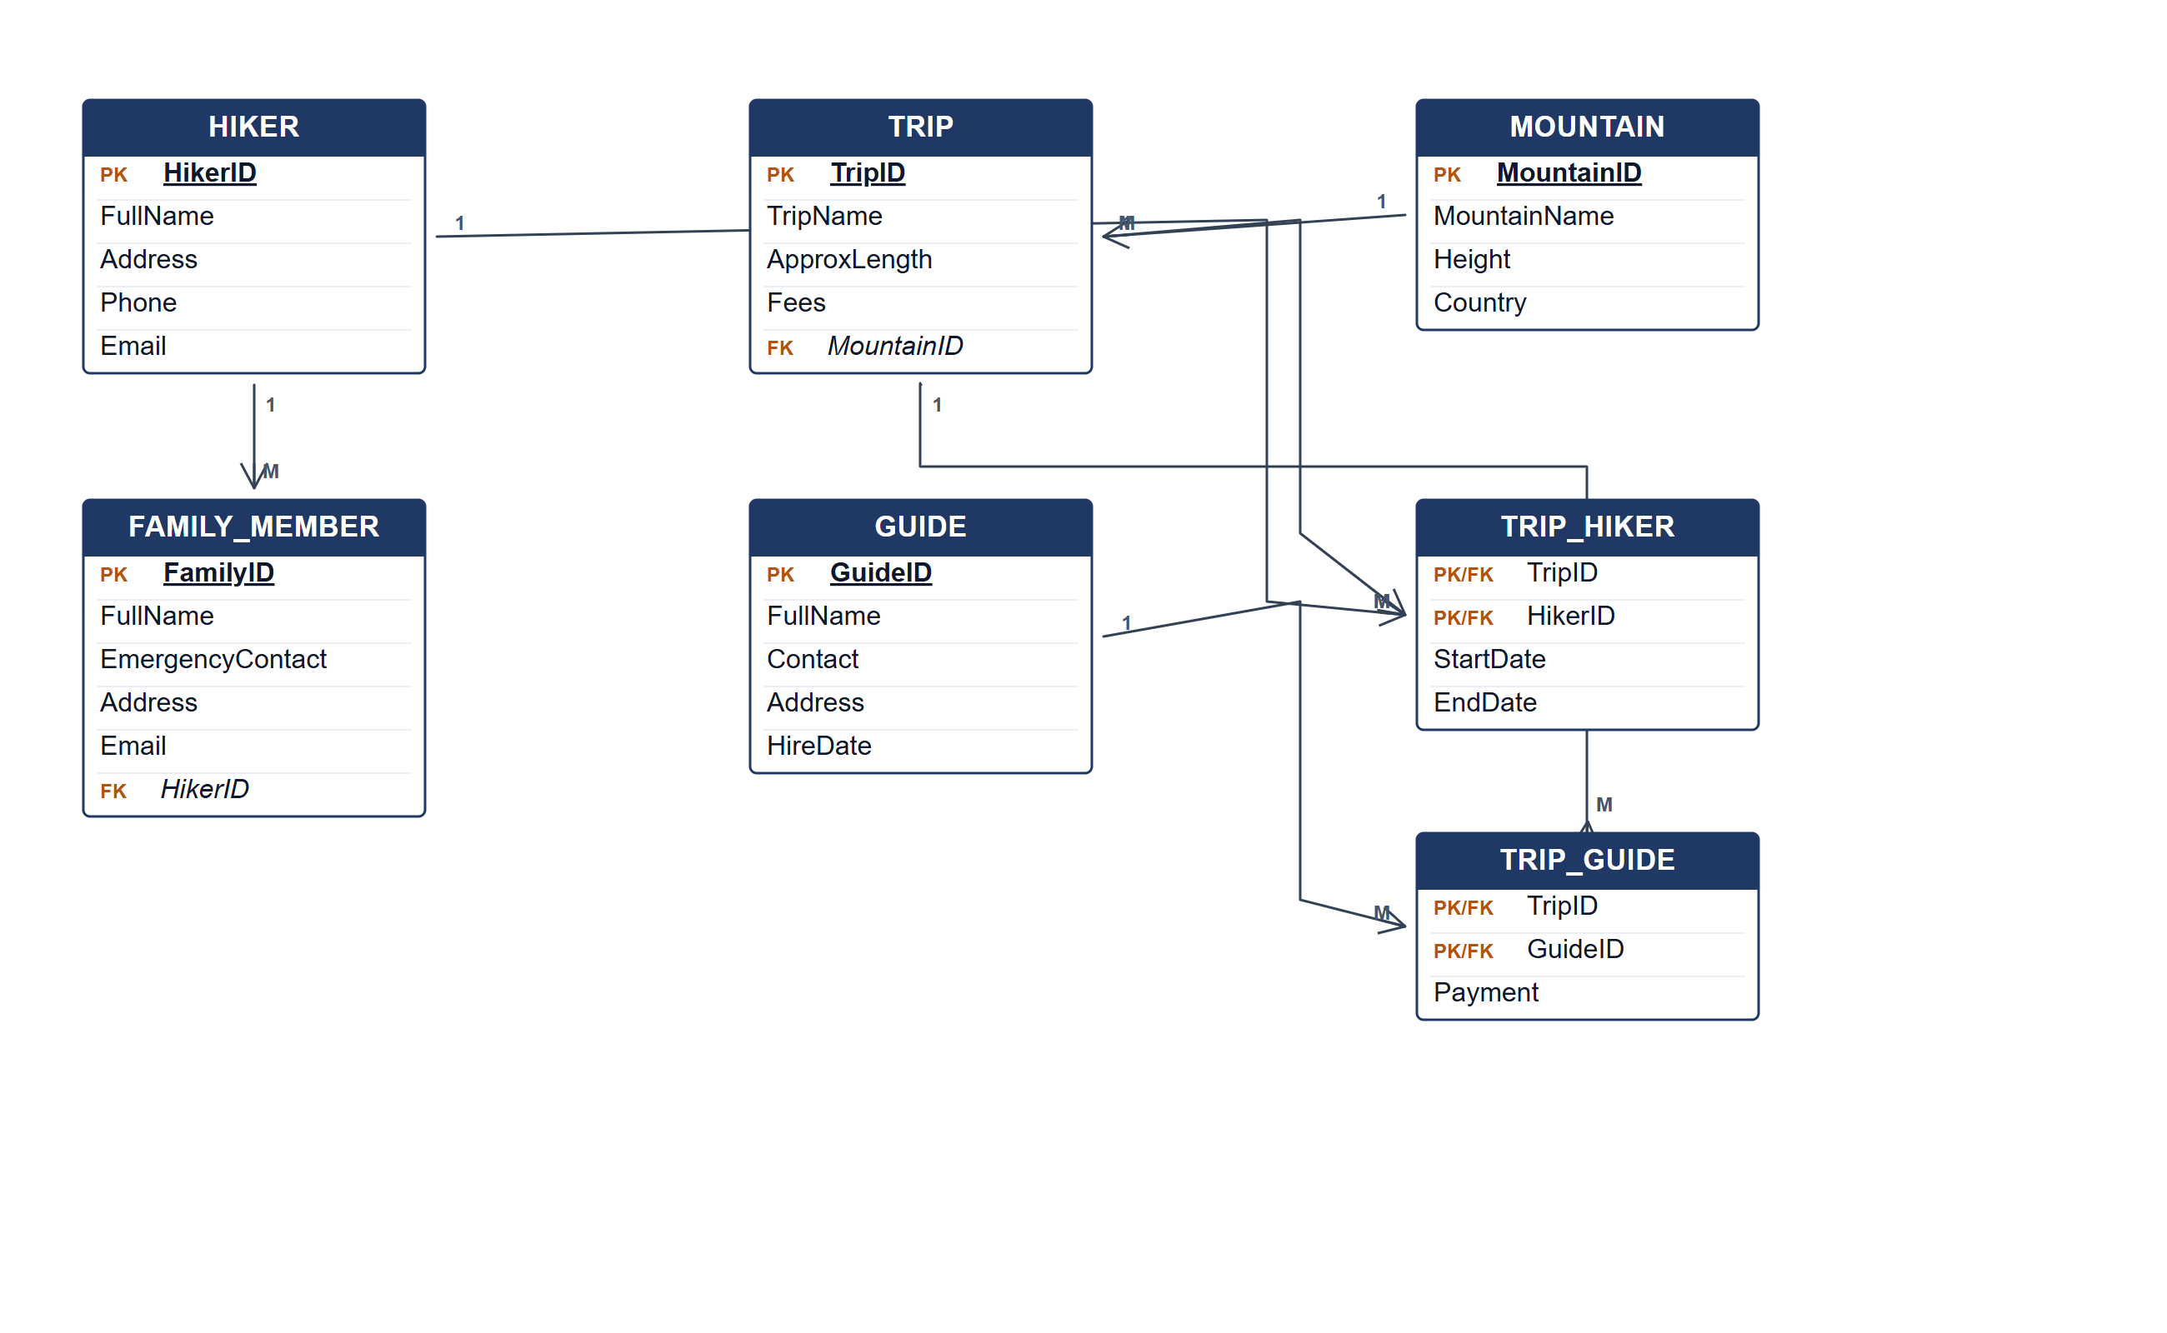
Bristledbeast ERD.
(b) Two reports from the ERD. [4 marks]
• Trip participation report — hikers, start/end dates and fees for each trip.
• Guide payment report — trips assigned to each guide with the recorded payment.
Marking guide
• a) 16 marks: hiker/family/trip/mountain (6); guide and two associative entities (5); relationships and cardinalities (3); keys (2).
• b) 2 marks for each report (4).
Provenance: model_unofficial · confidence medium · Model-authored from the approved question text, the supplied source assets and the ICT200/ICT450 knowledge base; no official ICT450 marking scheme was supplied.
Knowledge base basis: TOPIC 4 ERD_stu (2).pdf; TOPIC 3 RELATIONAL DATA MODELstu.pdf
Assumptions / notes
• Payment is an attribute of the trip-guide assignment; a hiker may have several family members.

